K–2 Food Chain Cards • Page 1: picture cards. Print on cardstock (or laminate) and cut along the dashed lines. Core chain: Sun → Water Plants → Small Fish → Fishing Cat. Challenge chains use the Crab and Snail.
Sun    I am a big, bright star! | Water Plants  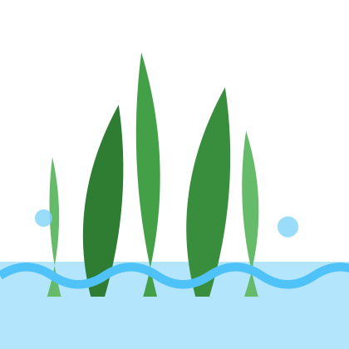  I grow in the water.
Small Fish  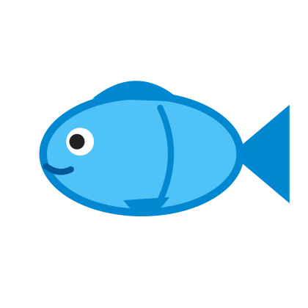  I swim in the water. | Snail    I glide on one foot.
Crab  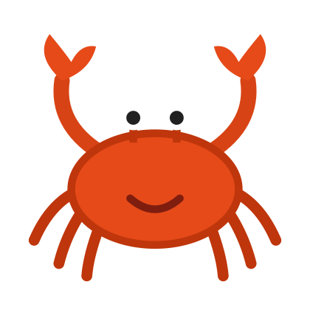  I have a hard shell. | Fishing Cat  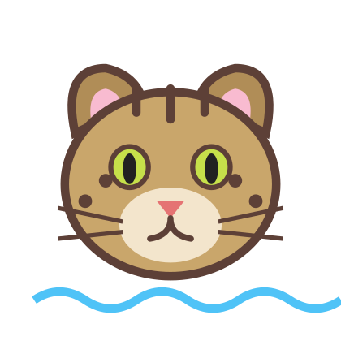  I hunt in the water!
Page 2: “Be the Chain” badges. Cut out, punch two holes at the top, and add yarn so four students can wear them.
Sun | Water Plants
Small Fish | Fishing Cat
Page 3: arrow cards (print extra copies as needed), Predator and Prey word cards, and one “draw your own” card.
Gives Energy To    Point the arrow toward the one that gets the energy. | Gives Energy To  Point the arrow toward the one that gets the energy. | Gives Energy To  Point the arrow toward the one that gets the energy.
Gives Energy To  Point the arrow toward the one that gets the energy. | Gives Energy To  Point the arrow toward the one that gets the energy. | Gives Energy To  Point the arrow toward the one that gets the energy.
Predator  Predator  An animal that hunts other animals. | Prey  Prey  An animal that is hunted by other animals. | My Organism  Draw it here!  Name: ______________

