Grades 3–5 Food Chain Cards • Page 1 of 4: organism cards. Print on cardstock (or laminate) and cut along the dashed lines.
Sun    The sun gives energy to almost every food chain on Earth. | Algae & Water Plants  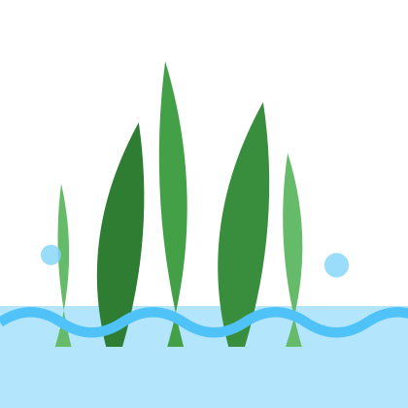  Some algae are too tiny to see without a microscope. | Snail    A snail glides along on one muscular foot.
Water Insect  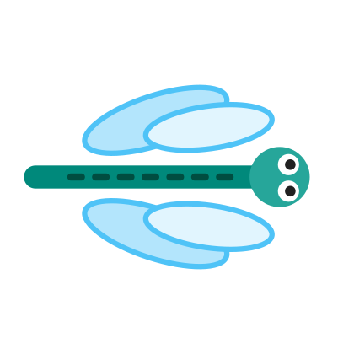  Some insects, like dragonflies, start life underwater. | Small Fish    Many small fish swim in groups called schools. | Crab  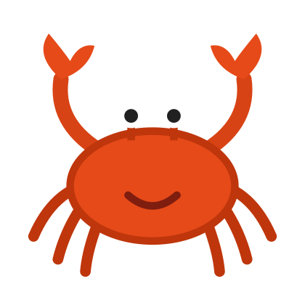  A crab has a hard shell and strong claws.
Frog    Frogs can live both in water and on land. | Rodent  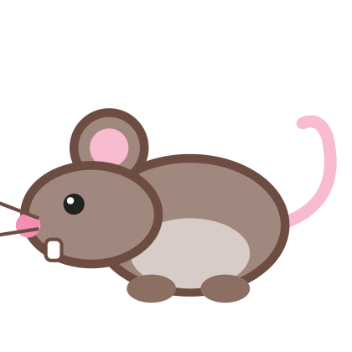  A rodent's front teeth never stop growing. | Fishing Cat    Its slightly webbed front paws help it hunt in water.
Page 2 of 4: three more organisms (snake, water bird, bacteria & fungi) and three “draw your own” cards for students who want to add another organism to their food web.
Snake  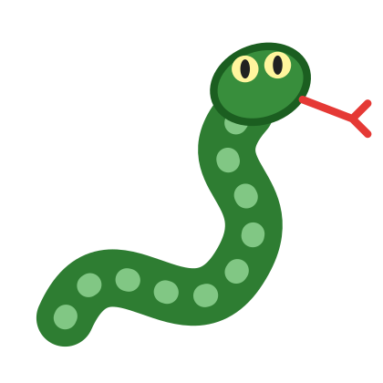  Snakes have no legs and move by flexing their bodies. | Water Bird  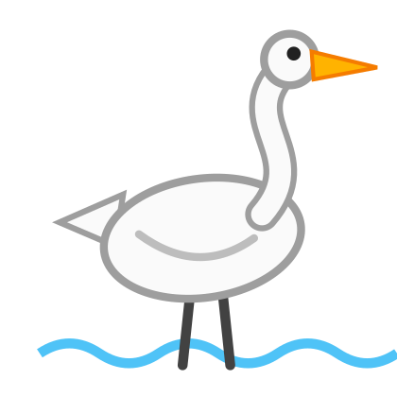  Long legs let wading birds stand in shallow water. | Bacteria & Fungi    Mushrooms are fungi. Bacteria are too tiny to see.
My Organism  Draw it here!  Name: ______________ | My Organism  Draw it here!  Name: ______________ | My Organism  Draw it here!  Name: ______________
Page 3 of 4: arrow cards. A full food web needs many arrows, so print two or three copies of this page per group.
Gives Energy To   | Gives Energy To | Gives Energy To
Gives Energy To | Gives Energy To | Gives Energy To
Gives Energy To | Gives Energy To | Gives Energy To
Gives Energy To | Gives Energy To | Gives Energy To
Gives Energy To | Gives Energy To | Gives Energy To
Page 4 of 4: role label cards. Students match these to organism cards when sorting producers, consumers, decomposers, and diet types.
Producer  Producer  Makes its own food using energy from the sun. | Consumer  Consumer  Gets energy by eating other living things. | Decomposer  Decomposer  Breaks down dead plants and animals and returns nutrients.
Herbivore  Herbivore  A consumer that eats plants. | Carnivore  Carnivore  A consumer that eats other animals. | Omnivore  Omnivore  A consumer that eats plants and animals.
Predator  Predator  An animal that hunts other animals. | Prey  Prey  An animal that is hunted by other animals. | Energy Source  Energy Source  Where the energy in a food chain begins.

