Grade 2 Food Chain Cards • Page 1 of 4: organism cards. Print on cardstock (or laminate) and cut along the dashed lines.
Sun    I am a big, bright star! | Water Plants  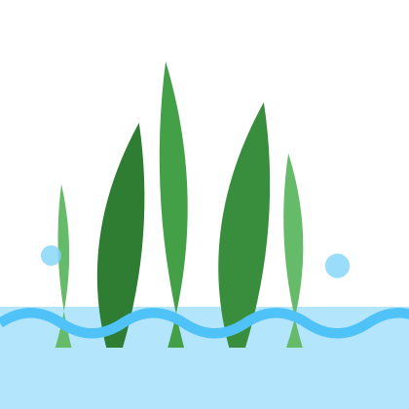  I grow in the water. | Snail    I glide on one foot.
Water Insect    Some of us start life underwater. | Small Fish    I swim in the water. | Crab  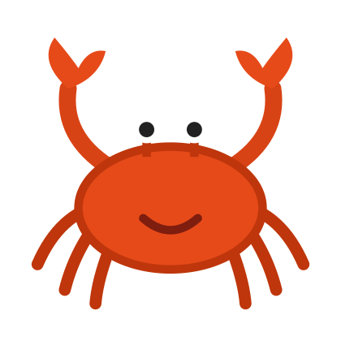  I have a hard shell.
Frog    I live in water and on land. | Rodent  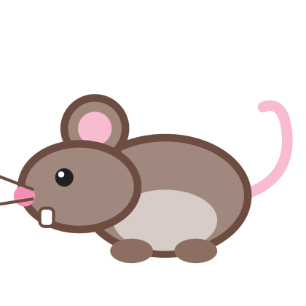  My front teeth never stop growing. | Fishing Cat    I hunt in the water!
Page 2 of 4: “Be the Chain” badges. Cut out, punch two holes at the top, and add yarn. Use four for the main chain (Sun, Water Plants, Small Fish, Fishing Cat) or five for the challenge chain (Sun, Water Plants, Water Insect, Frog, Fishing Cat).
Sun | Water Plants
Small Fish | Water Insect
Frog | Fishing Cat
Page 3 of 4: word cards (Producer, Consumer, Predator, Prey, Energy Source) and four “draw your own” cards.
Producer  Producer  Makes its own food using sunlight. | Consumer  Consumer  Eats other living things for energy. | Predator  Predator  An animal that hunts other animals.
Prey  Prey  An animal that is hunted by other animals. | Energy Source  Energy Source  Where the energy in a food chain starts. | My Organism  Draw it here!  Name: ______________
My Organism  Draw it here!  Name: ______________ | My Organism  Draw it here!  Name: ______________ | My Organism  Draw it here!  Name: ______________
Page 4 of 4: arrow cards. Print extra copies so every partner pair has enough arrows.
Gives Energy To   | Gives Energy To | Gives Energy To
Gives Energy To | Gives Energy To | Gives Energy To
Gives Energy To | Gives Energy To | Gives Energy To
Gives Energy To | Gives Energy To | Gives Energy To
Gives Energy To | Gives Energy To | Gives Energy To

