Does this lesson include? | - Primary sources  - Videos  - Graphic organizer
Lesson Title | A Tale of Twin Countries
Lesson Overview | Students will compare the apartheid movement in South Africa to the civil rights movement that took place in the U.S
Essential Questions | - What events led up to apartheid?  - What is apartheid? What was its purpose?  - What events led to the civil rights movement in the US?  - How were the black South Africans treated and how does it compare to the treatment of the black Americans prior and during the Civil Rights Movement?
Grade Level | 6-10
Subject | World History, World Geography, US History, African American Studies
Topic | Equal Rights
Subtopic | Cultural Characteristics
Standard | 7-1.3 Explain Africa’s current human population distributions and patterns, and use geographic models to compare the conditions driving migration and demographic change.  This indicator was designed to encourage inquiry into the distribution and pattern of human populations within the African continent, why they are located where they are, and how those patterns change over time through economic, environmental, and politically driven migration.
Duration | Two or Three - 45 minute class periods
Lesson Type | Formative and Summative
Recommended Technology | Smart board or presentation
Other instructional materials or notes
Lesson Partners
Images | 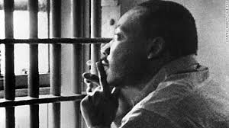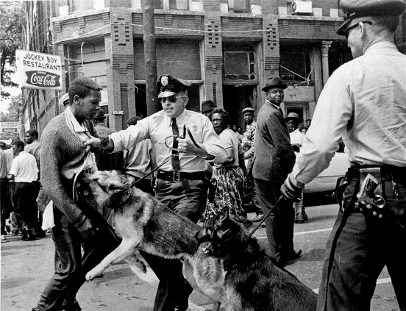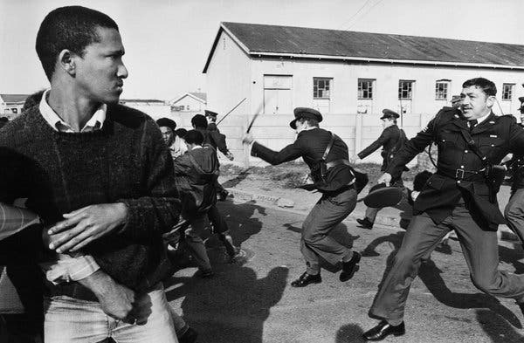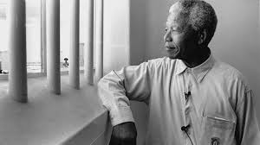
Lesson Progression | - Do Now: See-Think- Wonder (What do you see in these pictures? What do you think is going on? What do you wonder about the photographs?)  - Video: Clip of apartheid movement, clip of civil rights movement  - Graphic organizer: as a class, students and teacher will complete venn diagram explaining similarities and differences between the two movements  - Direct Instruction History/Timeline of Apartheid and events that led up to the situation  - Examine letters 12 letters from prison from Nelson Mandela (will also be used later)  - Students should answer the following questions for homework and to be used later in classroom discussion: Describe what you think Mr. Mandela was thinking and feeling based on his letters from prison.  - Students will then learn the history of the civil rights movement  - Students will read a letter from Birmingham jail.  - Students will discuss the thoughts and feelings of MLK  - Students will write an essay outlining both events and discussing similarities and differences.
Real World Connection | Students will write a paper discussing sentiments that led to injustice against blacks in the past and compare events that show those same sentiments still exist.
Assessments | Essay (above)
Resources | Letters from Nelson Mandela:  https://www.abc.net.au/news/specials/nelson-mandela/2013-12-06/nelson-mandela-letters/2900788  Letters from Martin Luther King Jr.:  https://teachingamericanhistory.org/library/document/letter-from-birmingham-city-jail-excerpts/  Apartheid Video:  https://www.youtube.com/watch?v=MOA66AOG52M  Civil Rights Video:  https://www.youtube.com/watch?v=C0JJHZUUAJU

