LearningWhy Lesson Contribution template:
Does this lesson include? | Evidence
Lesson Title | Math is Natural: Hair braiding and Patterns
Lesson Overview | The students will discover how the art of hair braiding can be used to teach and learn mathematics.
Essential Question | How can hair-braiding be used to teach the concepts of shapes, patterns, addition/subtraction word problems?
Grade level | 2nd
Subject | Math
Topic | Mathematics and hair braiding
Subtopic | Shapes, patterns, addition/subtraction word problems

Standard | ATO.1 Solve one- and two-step real- world/ story problems using addition (as a joining action and as a part-part-whole action) and subtraction (as a separation action, finding parts of the whole, and as a comparison) through 99 with unknown in all positions.
Duration | 2 days
Lesson Type | Fluency/procedural/application
Recommended Technology | Whiteboard/ laptops
Other instructional materials or notes | Pictures of children with braided hair
Lesson Partners | Here we will add your organization once we get a lesson uploaded.
Images | 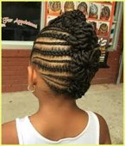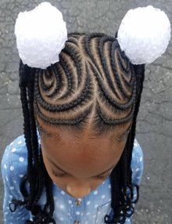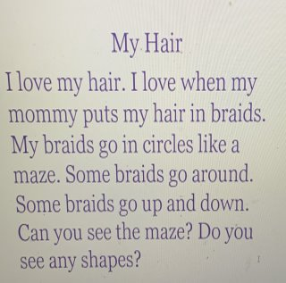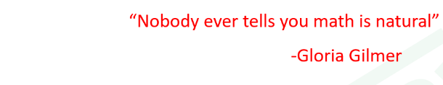  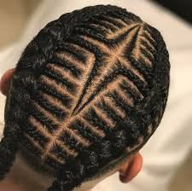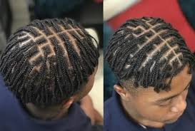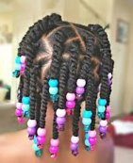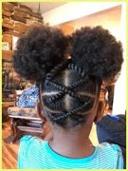  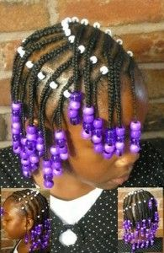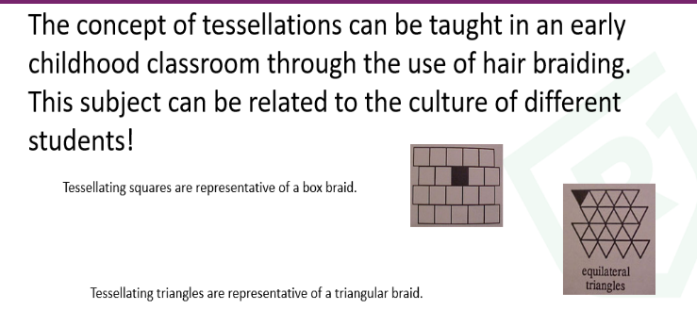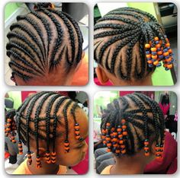  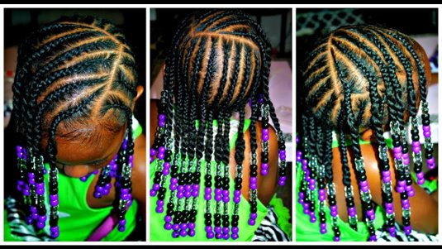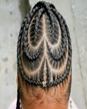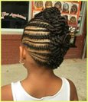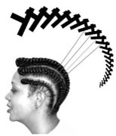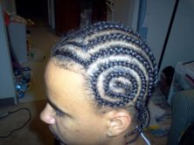
Lesson Progression | Day 1  - Teacher will review Dr. Gilmore and Ethnomathematics  - Teacher will show the quote, “Nobody ever tells you math is natural.” -Dr. Gloria Gilmer  - Ask students, what do they think this means?  - Show slides about Dr. Gilmore teaching patterns and shapes  - Show students different pictures of braids. Ask them if they see any patterns or shapes.  - Introduce tessellations/ patterns  - Show another picture of a pattern, ask the students to predict the next pattern. Show example of the writing with the picture.  - Students will record the types of shapes they see in the braids (3-4 pictures).  - Ask students, how the use of braids helped them with the information?  Day 2  - Review previous lesson.  - Show the slide of the little girl with purple and black beads. Ask students what different math equations can you teach using beads?  - Using this picture have students to create a addition fact and a subtraction fact.  - Model for students a word problem the picture with the purple and black beads. “Alayah has 7 braids. Each braid has 3 beads does she have in all? Give students the opportunity to solve. Review the parts of the word problem that the students must have.  - Teacher will show 1 more slide and ask students to create a word problem.
Teacher Notes | Use the slides provided to guide the students in the lessons.
Assessments | In journal, students will respond to the question, how is math natural? The students must give one example to support their answers.
Add Resources | With links and documents
 | Confirm submission

LearningWhy Lesson Expectations
Does this lesson include? | LearningWhy Expectation | Evidence
Standards | Specific SC state standards used are listed including any relevant indicators
Essential question | Engaging complex question, problem or challenge. This question leads to more student-centered investigating  and responding, requiring students to acquire a deeper knowledge through active exploration.  - Open-ended  - Understandable and inspiring to students  - Aligned with learning goals  - Answer will require justification from lesson  - Aligned with standards
Real World connection | Scenario/ simulation that is real or fictitious.  Requires a real-world task
Resources | Relevant ETV media resource (Knowitall.org or PBS Learning Media)  Relevant media resource (no copyright violations)  Relevant primary document (no copyright violations)  Relevant technology tools (required for one-to-one lessons)

