Benjamin Mays Historical Site Student Inquiry
ETV Education asked students from Benjamin E. Mays Elementary School in Greenwood, SC to investigate, analyze, formulate questions, and research potential captions for the Let’s Go Interactive of the Benjamin Mays Historical Site. The following are the images selected and questions asked by the students upon their analysis of the site:
Image | Question | Contributor
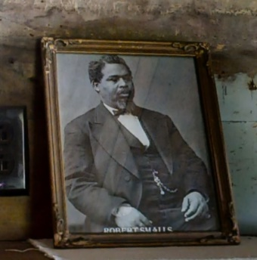 | Who was this person? | Myles
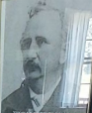 | Who is this man and why does Dr. Mays’ family have a picture of him? | Camryn
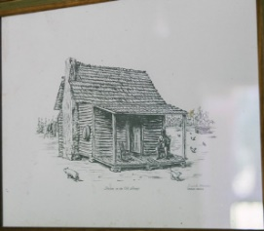 | Is this a drawing of Dr. Mays’ house? | Camryn
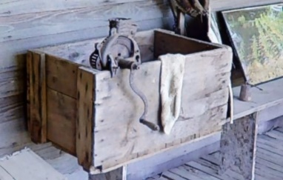 | What is this box used for and why did Dr. Mays have it? | Eustace
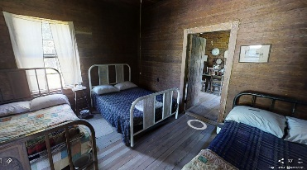 | Why are there 3 or 4 beds in one room? | Mallory
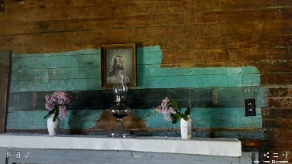 | Was Dr. Mays a Christian? | Wyatt
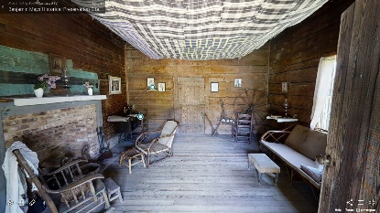 | Did Dr. Benjamin E. Mays ever relax in his living room when he was young? | Anthony
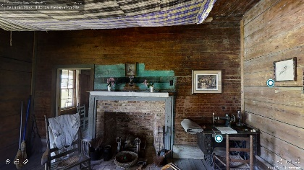 | Why is one section of the house turquoise, but the other parts are bare wood? | Blaire
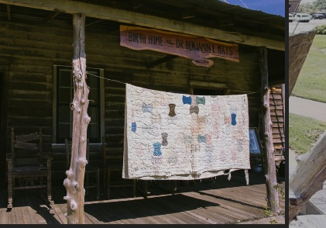 | Why is this quilt outside on the porch? | Sydney
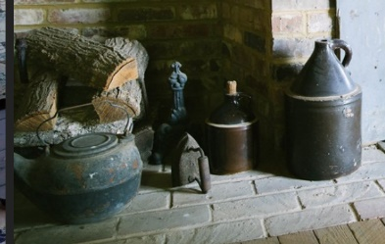 | Why are there a lot of jugs near the fireplace? | Anthony M.
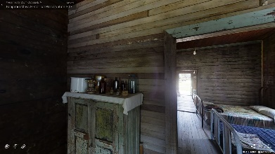 | What are these bottles used for on top of the cabinet?  What is in the cabinet? | Aiden
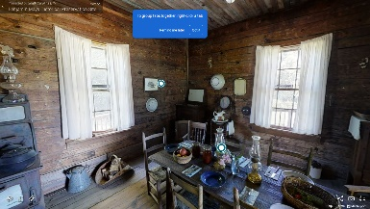 | How did Dr. Mays and his family cook? | Anthony W.
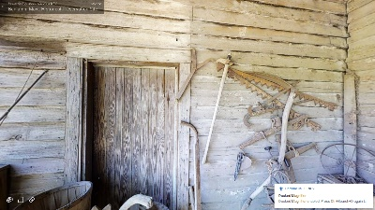 | Why does Dr. Benjamin E. Mays have these farming tools outside his house?  What are the uses for these tools? | Keelan
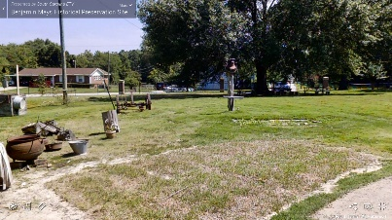 | Why does the Mays family have a bell in the yard? | Fischer
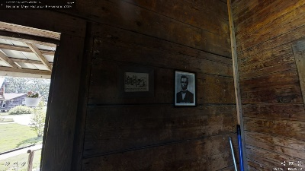 | Was Dr. Mays a fan of Abraham Lincoln? | Kevon
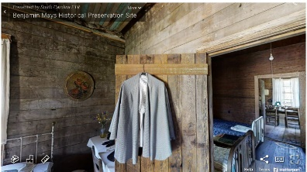 | Who wore the cape that is hanging on the door?  Did someone make the cape, or did they buy it from a store? | Anne Glawe
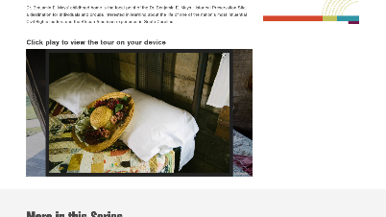 | Why is the hat decorated with flowers?  Where did they get the beautiful flowers on the hat? | Anne Glawe

We invite you to submit questions asked by yourself and/or your students so we can learn what others inquire regarding the life and home of Dr. Benjamin E. Mays.

